|  |  |  |
| --- | --- | --- |
| **LAB 321 Assignment** | **Type:** | **Long Assignment** |
| **Code:** | **J3.L.P0004** |
| **LOC:** | **300** |
| **Slot(s):** | **10** |

**Title: News Papers**

**Background**

Reading news in the internet now is new trend, especially young generation. We will make a simple digital new website, where you could find most of digital news.

**Program Specifications**

Program a digital news website, detailed functions of this website are described below

**Features:**

This website contains information of digital news

Note: All data must be loaded from database, not hard code.

***Expectation of User interface:***

Pic 01: News Page ( TOP)

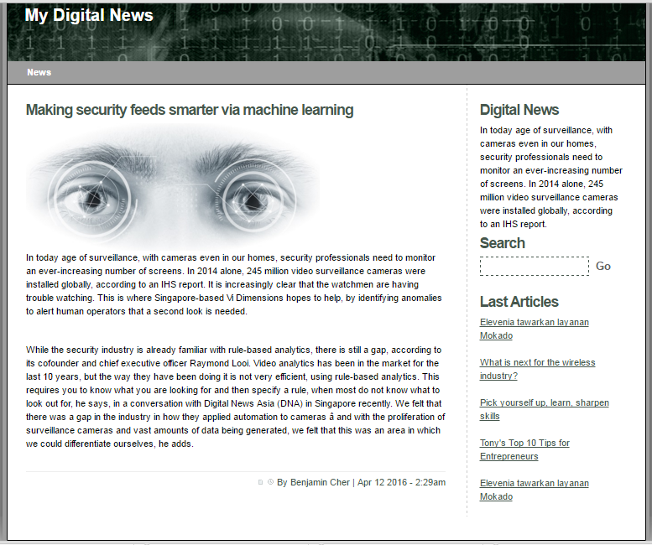

Search news by news title

Top 5 most recent news

The most recent news

Writer and date published

**Guidelines**

* Step 1 : Create prototype
* Step 2 : Design database based on created prototype
* Step 3 : Code & Test